Case Study: Passenger (2016)

# Introduction:

One of the recent movies about Sci-Fi that I found interesting for this article is the ‘Passenger’ movie. From the beginning of the movie, it is clear that this movie happens in the future. It is interesting to see that artificial intelligence has finally succeeded. The virtual reality crew member explains the rules and welcomes Jim, who wake up from hibernation way before he should. They have robot waiters, ‘expert systems’ as bartenders, intelligent vacuum cleaners, virtual reality games, etc.

Our main focus on this article will be the Hand Held device Jim and Aurora (Jennifer Lawrence) was shown having in a few scenes. I pick that over the rest of the interfaces because I can relate to that well and it one of those devices that already exists in today’s world. It is interesting to differentiate between the two and see the improvements.

# Handheld device:

# 

Figure - Aurora keeping the handheld device conveniently on the floor to read

The Handheld device (probably made by Homestead in the movie) is almost identical to what we have now. That is, I noticed it to be a hand held device just by looking at it from a second. I could relate to it in a second. It did not need any further explanation about its functions or capabilities. The only differences we notice is it is translucent. There is a holder in the bottom where there possibly could be buttons. They can interact with the device through hand or through voice commands.

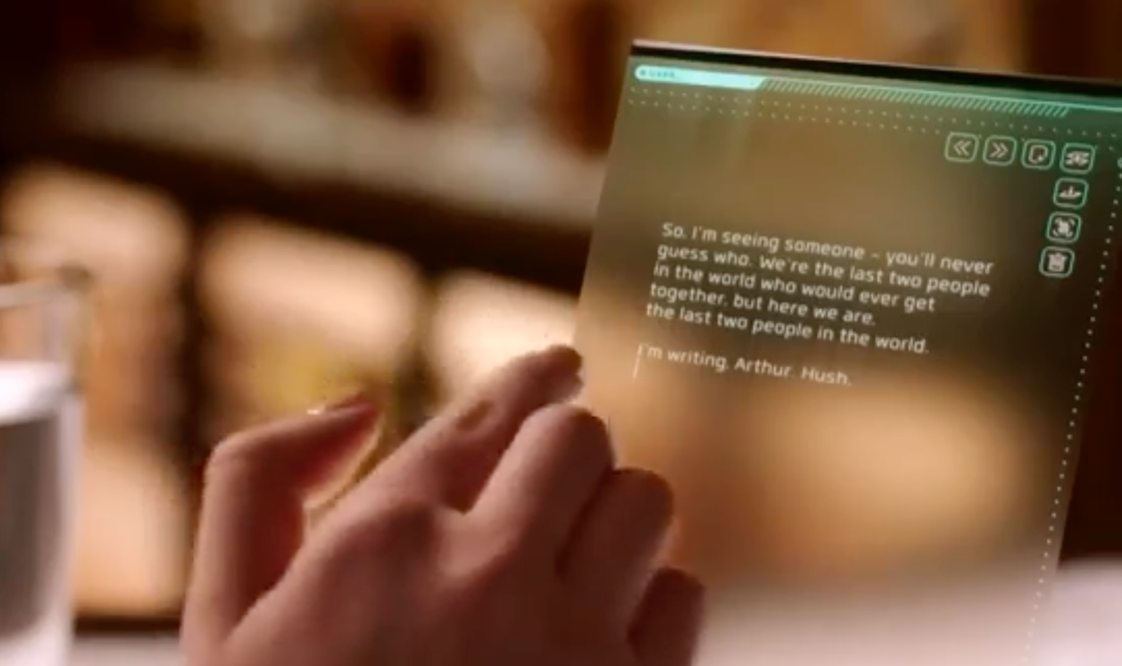

Figure - Aurora deleting the last line she entered.

The hand held device hasn’t changed much from the present. They still are ‘Picture Under Glass’. There are buttons on the screen for users to choose from. We still hold them with one hand or keep is horizontally or vertically on a surface. They can be used by one finger or any number of gestures that we use today, such as pinch and zoom or fling. The cast in the movie use it around a lot. Just like how we would carry our tablet wherever possible.

The concept of hand held devices have been around since the late 80s or early 90s. The first handheld devices had lots of buttons and had a small display. It could do simple computations and had very few functions. As years went by, these handheld devices have become more sophisticated. Now, they can do a number of functions and was faster. The concept of touch display was introduced. This reduced the number of buttons and instead increased the screen size. It also introduced the ability to have many buttons without complicating the device, unlike the old telephones explained in “The Design of Everyday things” by Donald A. Norman.

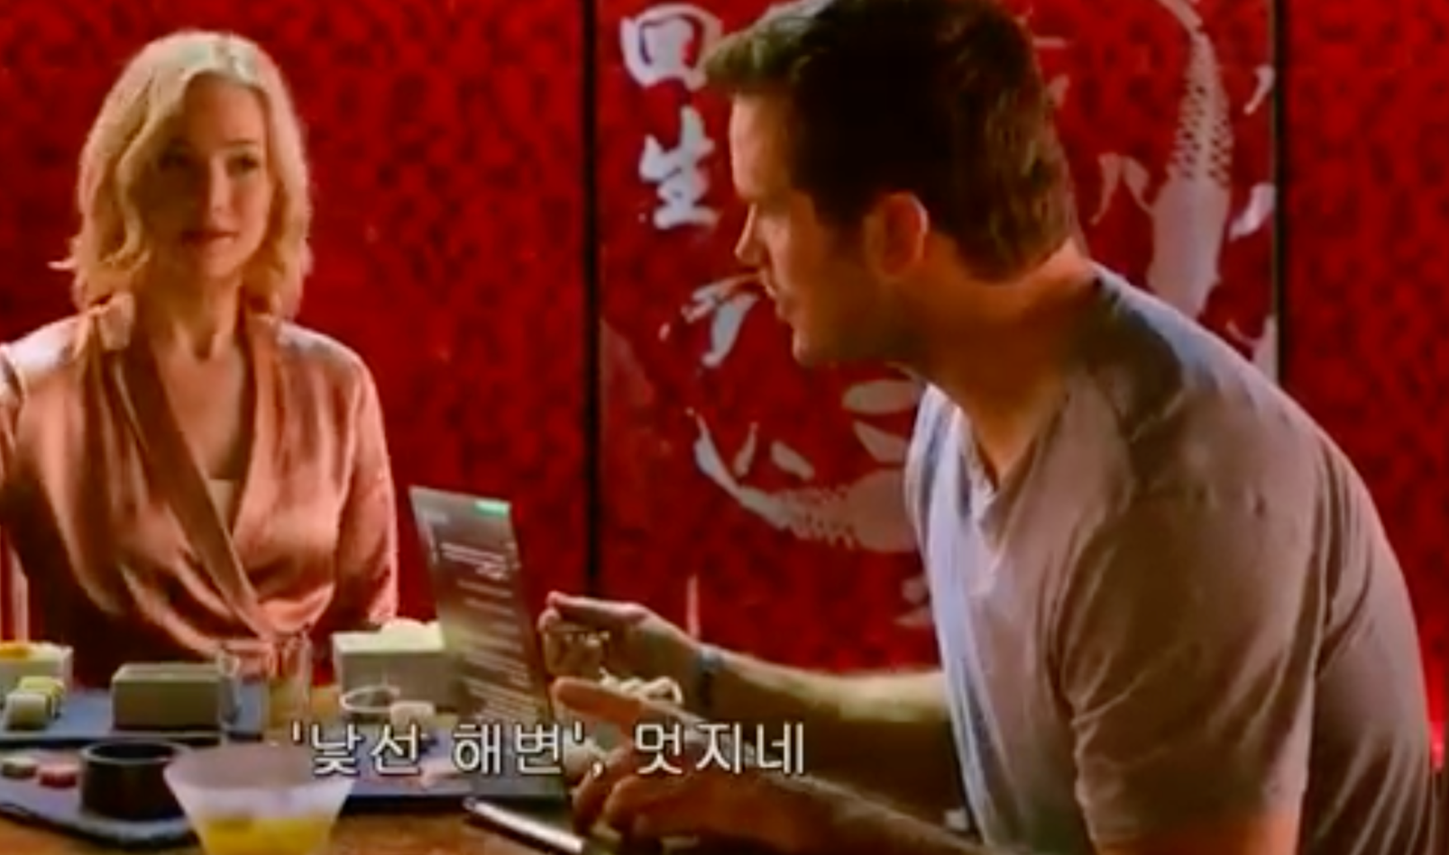

Figure - Jim reading Aurora's novel from the handheld device and using his fingers to go to the next page.

Yes, the technology was around for quite a while. It has gained popularity in the last 10 years. The handheld device in the movie looks simple to use, sleek and easy to carry around. It has a very good voice input software and is less error prone to what we have today. Though we have really good voice command applications, such as Siri, Google, Cortana, they are still error prone and is not 100 percent reliable.

Aurora uses it to write novels and read them. The fact that it is translucent seems to have no distractions or problems for people reading it. They do not show anything about how the handheld device is charged. As mentioned, Aurora uses it to write her novel using narration. (Figure 2) There is a scene where she wants to delete something and she just swipe backwards on the text and it erases. They are almost identical to what we have now. We select and delete but the future handheld device seems to have delete immediately. (Figure 1) Another improvement that is noticeable is the way the handheld device stands on the surface is lightly slanting and not fully straight. This makes it easy to read while sitting a little above the device while it is kept on the floor next to you. Today’s tablets are also slanting because of the cases that we put over it allows it to stand in a slanting position.

The device is an improvement to what we have currently in terms of intelligence. What is surprising is after all the breakthroughs in technology in the movie, they still use fingers to communicate with the device, unlike what Bret Victor in ‘A brief Rant on the Future of Interaction Design’ warned we should change. But from today’s perspective, the device is easy to use. Since the functions are on the ‘screen’, there are no complicated buttons to remember. It is easy to carry around and light weight.

One problem is how the devices are usable by old people or people with low deficiencies to color. The screen seems to have a green (sort-of) resolution and translucent that makes it hard to for a few people to see. Perhaps they have other settings but this was not shown in the movie.

We can conclude by saying that while the whole movie uses very simple interfaces throughout the spaceship. From the information lookup screen to the ordering food menu. They are simple interfaces and perform their own functions. This is similar to the current world so most of the devices and interfaces are easy to learn and pick up. The handheld devices haven’t changed a lot so it there not much we can improve for these handheld devices?